3.10 – One week to JWOC 2024

Junior World Orienteering Championships
Pilsen (Stříbro, Hůrky, Dobříč), Czechia – 1–6 July 2024

JWOC 2024 is getting closer!

Less than a week from now, on 1-6 July 2024, a world-class sporting event, the Junior World Orienteering Championships, will take place in the Pilsen region of Czechia. It will be the 34th championship overall and the third in the Czech Republic. The first one took place in 2000 in Nové Město na Moravě, and the last one in 2013 in Hradec Králové. We will provide information about the races and each location in this release.

Schedule, locations
- July 1, 2024, 4:15 p.m. – Sprint relay, Pilsen – Lochotín Amphitheatre. Overall event time approximately 1 hour. Followed by the opening ceremony.
- July 2, 2024, 10:00 a.m. – Sprint, Stříbro. Overall event time is approximately 3 hours and 30 minutes, with the best finishes expected after 12:00 p.m.
- July 3, 2024, 9:00 a.m. – Long distance race, Hůrky. Overall event time is approximately 7 hours, with the best finishes expected after 3:00 p.m.
- July 5, 2024, 9:00 a.m. – Middle distance race, Dobříč. Overall event time is approximately 6 hours and 30 minutes, with the best finishes expected after 2:00 p.m.
- July 6, 2024, 9:00 a.m. – Relay, Dobříč. Men's race starts at 9:00 a.m., women's race starts at 11:00 a.m., each race lasting approximately 1 hour and 45 minutes.
Media participation
We are honoured to welcome representatives from print, digital, and audiovisual media, as well as social media content creators, to both individual races and the entire championship. Comfortable facilities are prepared for the media, including accessible internet connection, charging stations for electronic devices, an information service, and light refreshments. A mixed zone with assistance for interviews with athletes and other championship participants is provided.
We also welcome representatives from media outlets not yet accredited. Accreditation can be easily arranged on-site at the media centre in the race arena or by prior arrangement at media@jwoc2024.cz or by calling 607 860 698.

Competition Progress, Participants
The championship will welcome over 330 competitors from around the world. A total of 38 national teams will participate, including several non-European teams such as Australia, South Africa, New Zealand, and the USA.
In the sprint relay competition, mixed teams consisting of two women and two men will compete; men run two middle legs. The race takes place in an urban terrain. It is a mass start, with the first team to finish being the winner. The start, finish, and exchanges are located in an attractive amphitheatre. The race is fast, short, and highly attractive for spectators. Additionally, it is held directly in Pilsen, making it easily accessible by public transport and on foot.
Sprint is an individual discipline, with each competitor running at their own time, and times are evaluated at the end. The race will be run in the historic settings of the town of Stříbro. The discipline is fast, dramatic, and often brings unexpected twists.
The long distance and the middle distance races are also run with interval starts. The classic course primarily tests endurance and the ability to make complex decisions during long course legs across the landscape, while the short course focuses on speed, pace changes, and the ability to work with a detailed map in complex terrain.
The final relay race will be run with a mass start, with men and women running separately, and each team has three members.

Further information:
- This press release is numbered as 3 with the first two releases being in the Czech language, pertaining mainly to the local aspects of the competition and the Czech national team.
- Previous press releases and other downloadable materials are available on the championship website: https://jwoc2024.cz/en/media-2/downloads/
- Information on parking, arrival, and other technical details are available on the championship website.
Photos
Suitable photographic documentation of the championship's progress and photographs of national team members are available in the world championship photo archive: https://jwoc2024.zenfoliosite.com/media-kits-1
The galleries will be expanded every day as the championships progress. Check back often!
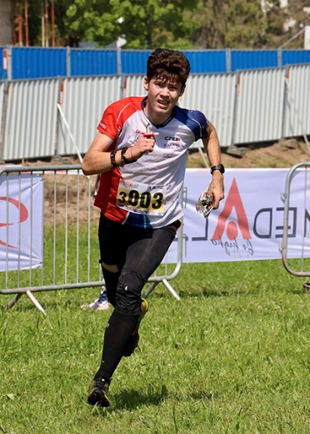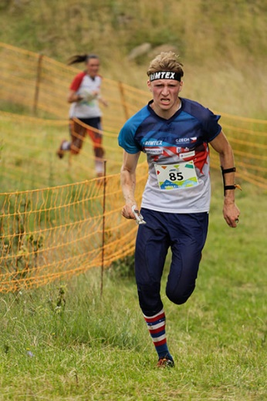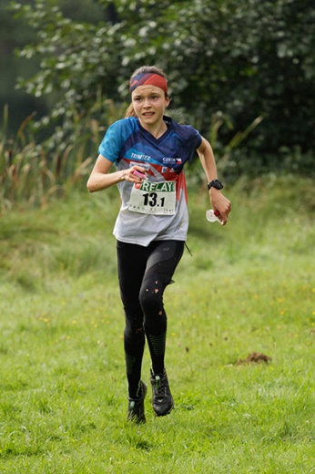
Contacts, links
Official website | http://jwoc2024.cz/
Czech O-Tour adjacent races | https://o-tour.cz/
Facebook | https://www.facebook.com/jwoc2024
Instagram | https://www.instagram.com/jwoc2024/
Photo archive | https://jwoc2024.zenfoliosite.com/
Inquiries, media mailing list addition | Dan Dvořáček, media@jwoc2024.cz, 607 860 698

